 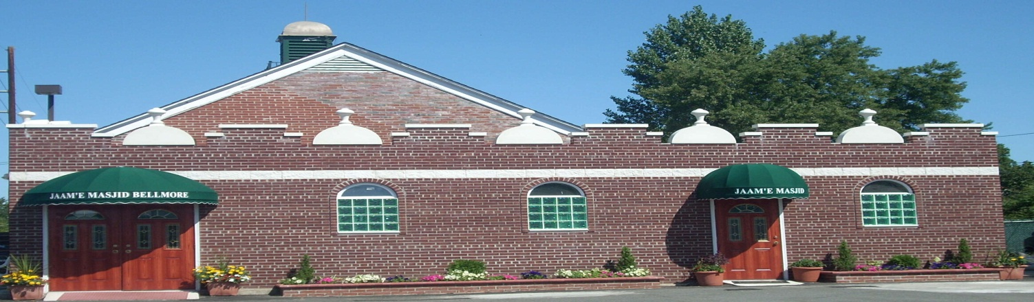

**Fundraising - Donation/Pledge Form**

*“Those who (in charity) spend of their goods by night and by day, in secret and in public have their reward with their Rabb. On them shall be no fear nor shall they grieve.” (Quran, 2:274)*

**Donor Information:**

*Name:* __________________________________________________________________

*Address:* _________________________________________________________________

*Home* [*Phone: _______________________*](Tel:________________________)_ *Cell Phone*: _____________________________

*E-Mail*:__________________________________________________________________

**Payment Information:**

□ Enclosed is my check/cash in the sum of $_______________. Please make check(s) payable to: ***Jaam’e Masjid Bellmore***

□ Please charge my donation to:

**Check one:** Visa □ Mastercard □ AMEX □ Discover □

*Credit Card Account Number*: _______________________________________ *Donation Amount: $_____________*

*Name (As it appears on credit card):* _____________________________________ *One Time Donation □*

*Expiration Date:* ___/ _____ *CVC (3 digit security code on the back of the card):* ____ *Monthly Recurring Payment □*

Please Note: 1. The address above must match the address that is associated with your credit card. 2. If you select the monthly recurring payment option, the Donation Amount above will be charged monthly until you cancel.

**Pledge information:**

I pledge to support Jaam’e Masjid Bellmore. I pledge a total gift of $__________________________.

Pledge Period (Optional):

This pledge will be payable in: [ 1 ] [ 3 ] [ 6 ] or ___ Months

*Signature: ­­­___________________________________*

*All donations are tax-deductible.*

**Executive Committee:**

**President:**

Syed Fahad Qamer

**Vice President:**

Azhar Aslam

**General Secretary:**

Asim Mateen Khan

**Joint Secretary**

Amir Zafar

**Treasurer:**

Shakeel R. Nauman

**Board of Directors:**

**Chairman:**

Javaid A. Ratcher

**Vice Chairman:**

Syed Zia ul Haque

**Board Members:**

Abdul Malik. Khan

Aslam M. Baig

Anis R. Siddiqui

Javaid A. Ratcher

Khalid Naseem

Najmul Huda

Mohammad Qamar Khan

Syed Zia ul Haque

Shakeel R. Nauman

Syed Fahad Qamer

Amir Zafar

Azhar Aslam

Asim Mateen Khan

1425 New Bridge Road, Bellmore NY 11710. Telephone: (516) 785-1426; Fax: (516) 612-0073; www.bellmoremasjid.org

Est. 2001