 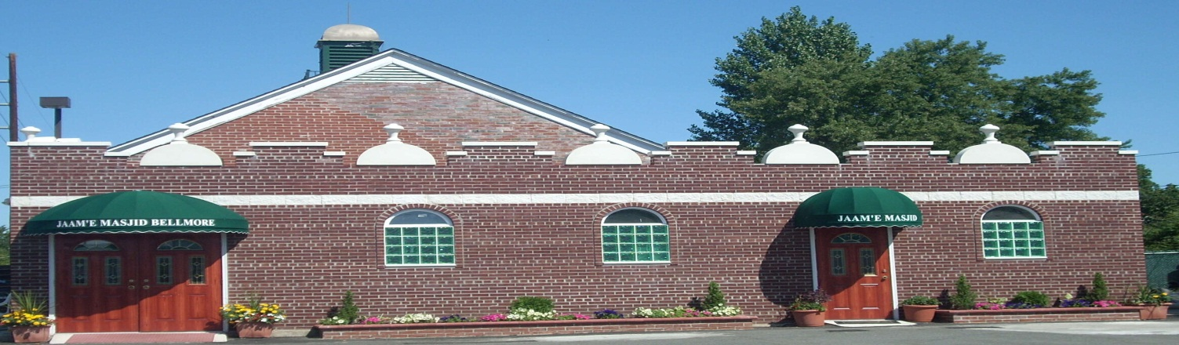

# Automatic Withdrawal Authorization

I (We), ________________________________________ authorize _________________

Your name or Company/Business name Your bank name

______________________ Bank to pay/transfer on _______ of each month starting from

____/____/____ $_____________ (_________________________________) to Jaam’e

Amount in words (for example: one hundred dollars)

Masjid Bellmore, out of my (our) checking/savings, till I (we) cancel.

Account # _____________________________ Routing # _________________________

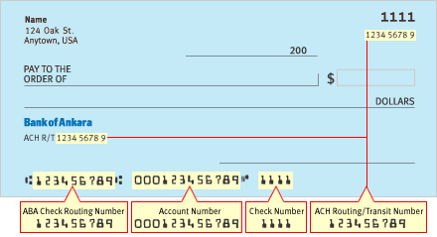

Mailing Address: _________________________________________________________

Email Address: ___________________________________________________________

Telephone: __________________________________

Signature 1: ________________________ Date:_____________________

Signature 2: ________________________ Date: _____________________

**Please make your donation checks Payable to JAAM'E MASJID BELLMORE Inc. All donations are tax deductible.**

**Executive Committee:**

**President:**

Syed Fahad Qamer

**Vice President:**

Azher Aslam

**General Secretary:**

Asim Mateen Khan

**Joint Secretary:**

Amir Zafar

**Treasurer:**

Shakeel R. Nauman

**Board of Directors:**

**Chairman:**

Javaid A. Ratcher

**Vice Chairman:**

Syed Zia ul Haque

**Board Members:**

Abdul Malik. Khan

Aslam M. Baig

Anis R. Siddiqui

Javaid A. Ratcher

Khalid Naseem

Najmul Huda

Mohammad Qamar Khan

Syed Zia ul Haque

Shakeel R. Nauman

Syed Fahad Qamer

Azar Aslam

Asim Mateen Khan

Amir Zafar

1425 New Bridge Road, Bellmore NY 11710. Telephone: (516) 785-1426; Fax: (516) 612-0073; www.bellmoremasjid.org

Est. 2001